Rabbi Carole B. Balin, Ph.D.
_____________________________________________________________________________
PUBLICATIONS

Books

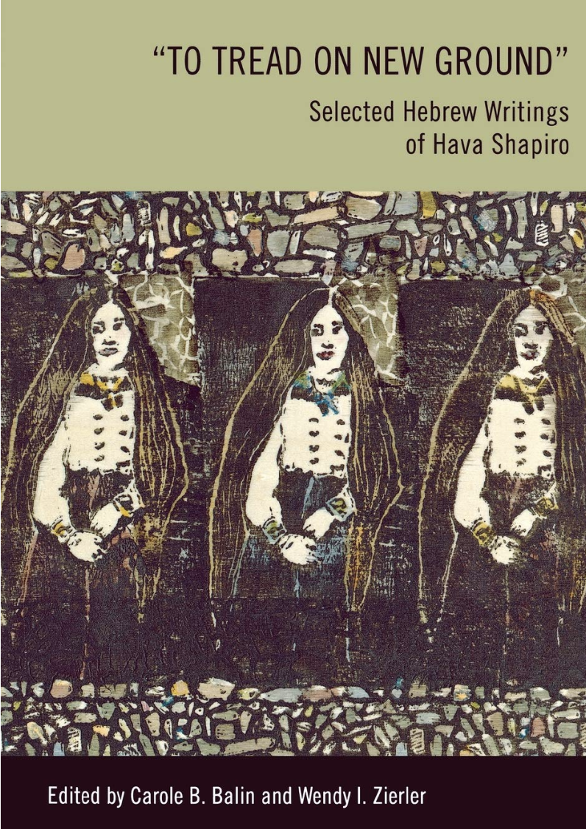

‘To Tread on New Ground’: Selected Hebrew Writings of Hava Shapiro, co-editor with Wendy I. Zierler, Wayne State University Press, 2014.

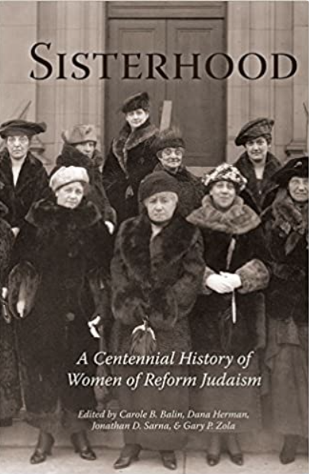

Sisterhood: A Centennial History of the Women of Reform Judaism, co-editor with Dana Herman, Jonathan D. Sarna and Gary P. Zola, HUC Press, 2013.

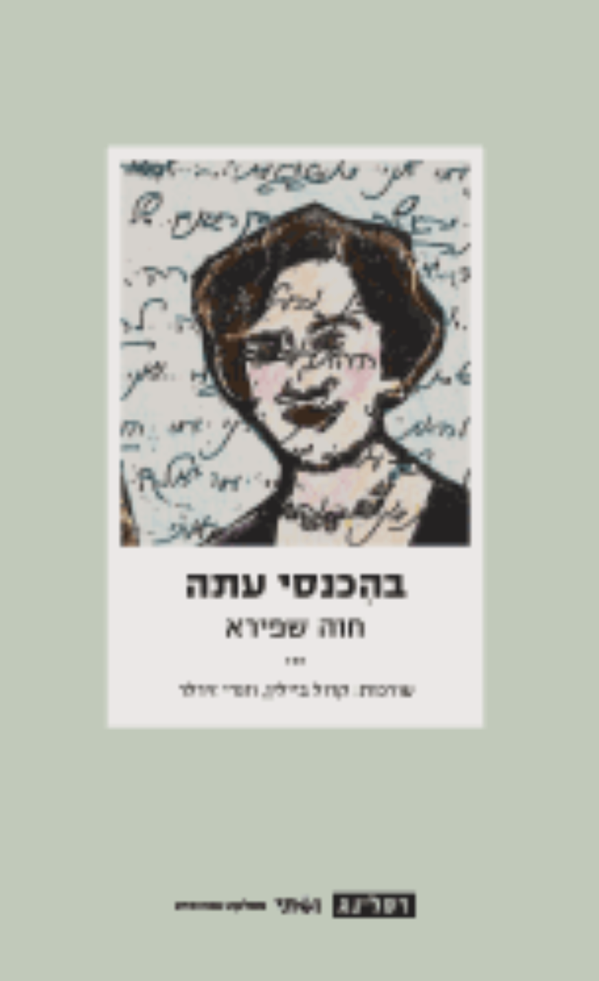

Behikansi atah [In my entering now; Anthology of Hebrew writings by Hava Shapiro with
scholarly afterword], co-editor with Wendy Zierler, Vashti Series for Women, Resling Press, Tel Aviv, 2008.

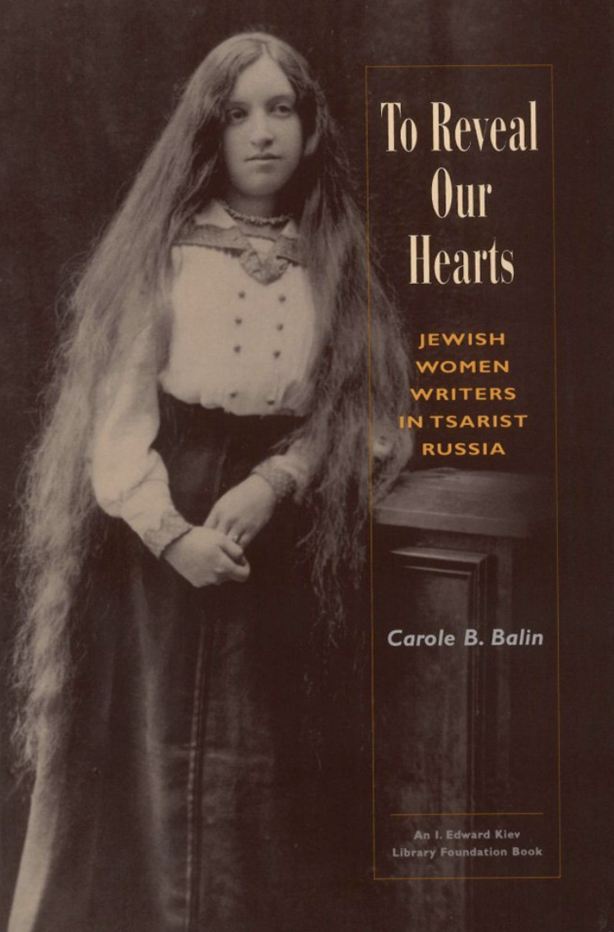

To Reveal Our Hearts: Jewish Women Writers in Tsarist Russia, HUC Press, 2000 (re-issued in paperback in 2003)

Recent Podcasts/ TV and Radio Appearances

NPR, “All Things Considered,” The Bat Mitzvah Turns 100

KCRW, “Press Play with Madeleine Brand,” Century of bat mitzvah: Ceremony for girls paved way for first female rabbi

Jewish Women’s Archive, “Can We Talk?,” Bat Mitzvah at 100

KCRW, “Good Food” with Evan Kleiman, Maxwell House Haggadah: How a Coffee Company Influenced Passover

PBS, “The Jewish People: A Story of Survival”

Recent Articles/ Commentary

“The Bat Mitzvah Turns 100” The Forward

“Are Women Counted in the Book of Numbers?” (9-part series), ReformJudaism.org

“Wives to the Rescue: The CCAR’s Epic Decision to Ordain Female Rabbis in 1922,” CCAR Journal: The Reform Jewish Quarterly, Summer 2022.

“Bat Mitzvah: American Jewish Women,” The Shalvi/Hyman Encyclopedia of Jewish Women

“Mitzvah/Mitzvot,” A Life of Meaning: Embracing Reform Judaism’s Sacred Path, ed. Dana Evan Kaplan, CCAR Press, 2018.

“The (Re)production of a Maskilah: The Mother-Daughter Bond between Menuhah and
Hava Shapiro,” with Wendy Zierler, in Mothers in the Jewish Cultural Imagination, eds. Marjorie Lehman, et. al. Littman Library of Jewish Civilization, 2017.

“Betty Friedan’s ‘Spiritual Daughters,’ the ERA and the CCAR,” in The Sacred Calling: Forty
Years of Women in the Rabbinate, CCAR Press, 2016.

